1.2 MODERN NETWORK ARCHITECTURE TECHNICAL DESCRIPTION

Description:
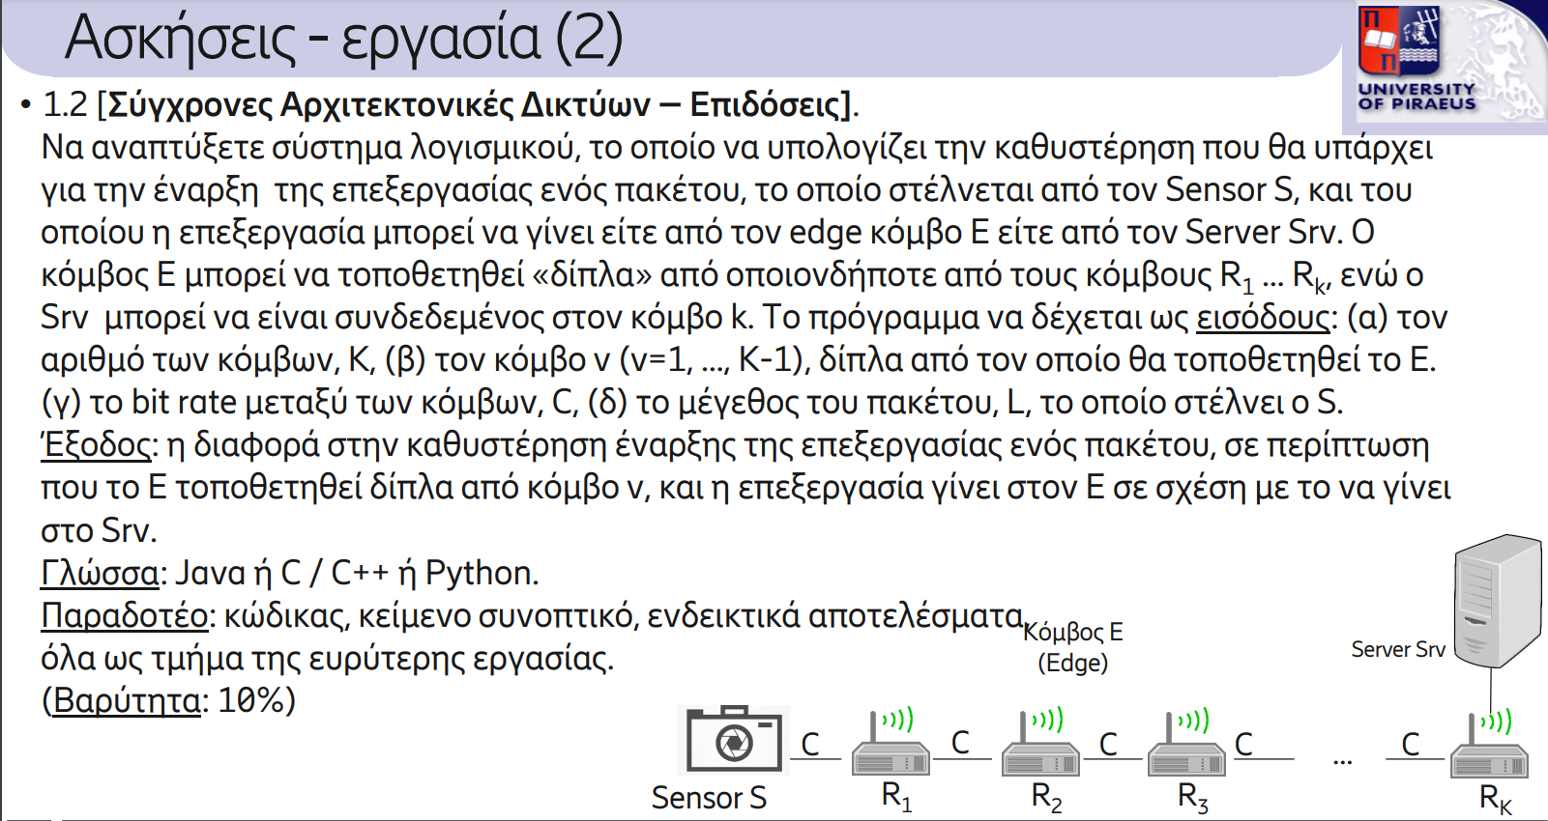

Solution:
The program must calculate between sensor S and the server and the delay between sensor S and an edge E and calculate the difference between them. User must insert the number of nodes, the node where we want to set the edge E, bit rate C in Mbps and the packet L in Mbytes.

Inputs:

Nodes K:
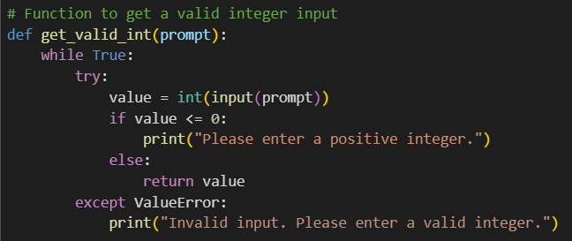
The method get_valid_int() is used to insert the number of nodes user has. That number must be a positive integer value. If is not, then it is displayed error message and user is asked to insert again the number of nodes
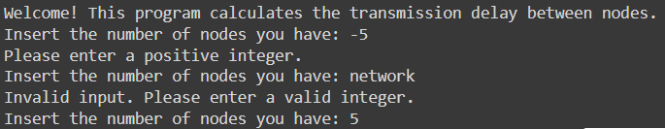

Edge E:
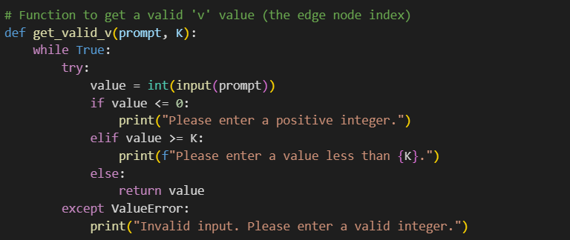
Method get_valid_v() ensures that user inserts an integer positive value between 1 and K-1 where K is the number of nodes we have in our network(it has no value to link our edge in the last node that is linked to the server Srv. If user inserts an invalid number, then an error message is displayed, and user must insert a value again.
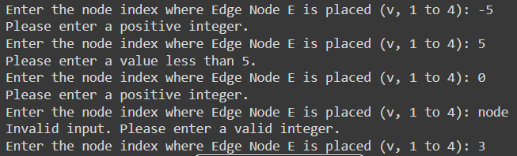
Bit Rate C & packet size L:
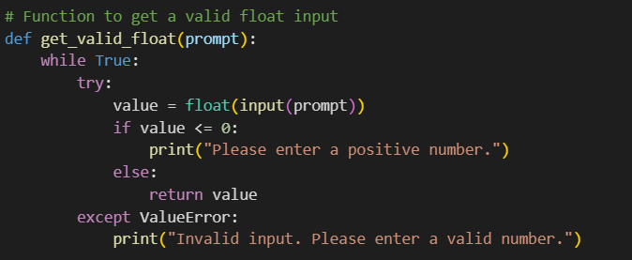
Method get_valid_float() ensues user to insert positive float value and it is used to insert Bit Rate C &packet size L. if the value does not meet the expectations, an error is displayed and the user must insert the value again.
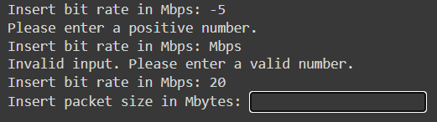

Delay calculation:
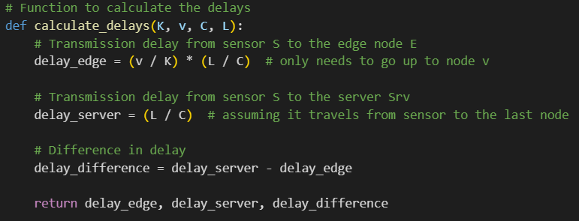
In order to calculate delay from sensor S to server Srv, from sensor S to edge E and the difference of those to, method calculate_delay() is called. The delay from the sensor to the server is calculated by dividing the packet size L with the bit rate C. The delay from the sensor to the edge is calculated by multiplying the ratio the index of edge to total nodes with the server delay. The difference is calculated by subtracting the S-Srv delay with the S-E delay. The method returns those 3 delays
Main():
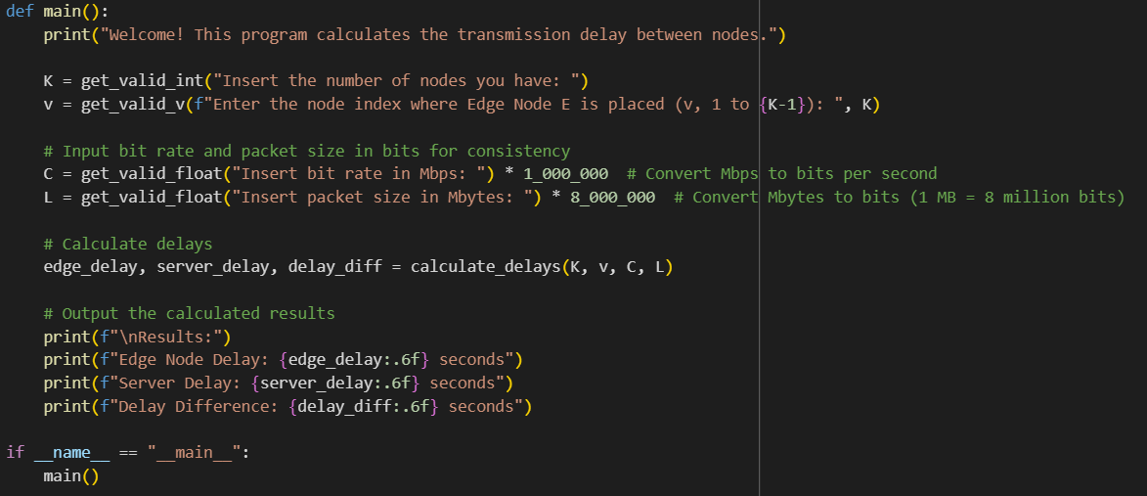
In the main function, K, v, C & L are inserted by the user with the help of the methods described above. Bit rate C is multiplied by 1000000 so we convert Mbps to bits per second and packet size is multiplied by 8000000 so we convert Mbytes to bits. Then, delays are calculated by using method calculate_delays() that is described above and results are printed.

Outputs:
